The contributing companies and their principal members to the lmveloyami Environmental Proiects and Consulting Joint Venture as listed below:
Member: Linda Bethuel Mlotshwa
Company Name: lmveloyami Environmental Projects and Consultants (Pty)
Registration Number: 2O17 /291717 /07
Address: M104 Esivivaneni Road, Hammersdale, Ntshongweni, 3599
&
Member: Wayne Rowlands Stead
Company Name: Legal, Environmental and Associated Developments t/a Lead Associates
Registration Number: 2004/096848/23
Address: Unit 45, 369 King Dinizulu Road, Durban,400

I do hereby grant, Linda Bethuel Mlotshwa, of lmveloyami Environmental Projects and Consultants (Pty) Ltd authority to sign all documentation related to the submission the following eThekwini Municipality tenders:
1N-29048
1N-29050
Thus done and signed at on day of November 2024.

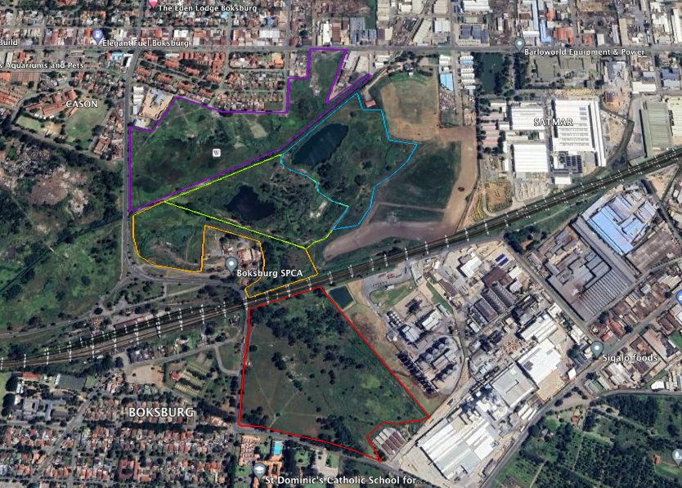
On a quick walk through of the Municipal owned land along with large amounts of refuse on the property the following species were identified.
- Common milk thistle
- Spear thistle
- Moonflower
- Common reed
- Eucalyptus trees and Shrubs
The list will be updated once the area has been ground truthed with the municipal members.
The 15 people employed would come from the nearby informal settlement and be trained and monitored on the below clearing methods. The correct tools and equipment will be issued to each of the workers to ensure that the clearing methods is adhered too. Daily check will be done to ensure that the standards are adhered too. After the first control has been completed there will be two follow-up sessions within the following 6 months to control seed bed germination and or coppicing.
We will be concentrating on 3 methods of control on the property, hand pulling, cut stump/ slashing and ring barking/basel stem.
Chemical control will also be applied where necessary when either the cut stump/slashing or ringbark/basil stem methods of removal is used.
Biomass will be stacked or spread across the area to mitigate erosion or removed from site to the municipal dump.

